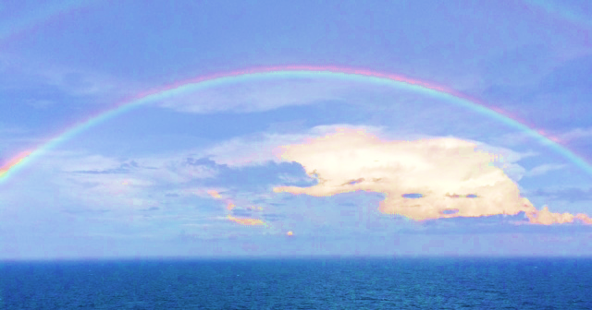

…of Natural Healing and Self-Care!

Give yourself the promise…

**Mindfulness Based Self Care (MBSC**)©

Eight Group Sessions -- $90

Tuesdays 6 - 7:30 PM

(February 24, March 3, 10, 17, 24, 31, and April 7, 14)

Physicians Care - 805 Montague Avenue

**Presented by...**

***Nurse Navigators 4 Integrative Healing***

***www.nursenavigators4integrativehealing.org***

**Sponsored by...**

***Jed Graham, MD***

***www.gwdpc.com***

To register call or email:

***Barbara Warner***

678-427-1404

*barbara@nursenavigators4integrativehealing.org*

***THE ART OF BEING MINDFUL***

**…finding peace in a stressed out world**

**Mindfulness Meditation** opens your door to self-care.

**Self-care** is your path to wellness and wholeness.

***Mindfulness*** is the natural state of living moment by moment

empowering balance of mind, body, and spirit...supporting your body’s ability to heal